1. **What is Express.js and why is it used? How do you install Express.js in a Node.js project?**

Ans: **Express.js** is a minimal and flexible Node.js web application framework that provides a robust set of features for building web and mobile applications. It is widely used for creating server-side web applications and APIs due to its simplicity and performance.

Express.js is widely used in Node.js applications due to its simplicity, flexibility, and a robust set of features that make web and API development more efficient. Here are the main reasons why developers choose to use Express.js:

1. Simplified Routing
2. Middleware Support
3. Dynamic Content
4. RESTful API Development
5. Extensibility

* **npm install express** is used to install the express in node

**2. How do you create a simple Express.js server?**

Ans: Create a file named app.js (or any name you prefer) in your project directory and add the following code to set up a basic Express server:

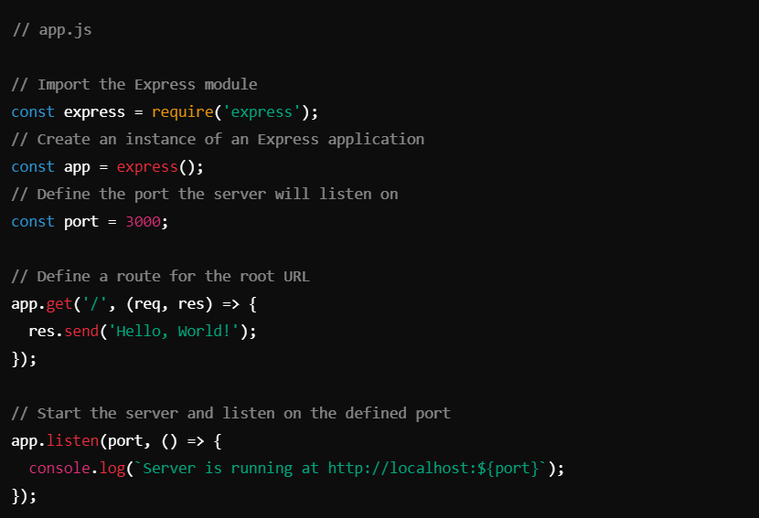

1. **What is a RESTful API? How do you set up a basic Express.js server for a RESTful API?**

Ans: A RESTful API is an application programming interface (API) that adheres to the principles of Representational State Transfer (REST). REST is an architectural style that defines a set of constraints and principles for creating web services. The key principles of RESTful APIs include:

* **Stateless**: Each request from a client to the server must contain all the information needed to understand and process the request. The server does not store any client context between requests.
* **Client-Server Architecture**: The client and server are separate entities that interact through a standardized interface. This separation allows for the independent development and evolution of the client and server.
* **Uniform Interface**: The interface between the client and server must be consistent and standardized. This often involves using standard HTTP methods (GET, POST, PUT, DELETE, etc.) and status codes.
* **Resource-Based**: Resources are identified by URLs (Uniform Resource Locators), and operations are performed on these resources using standard HTTP methods.
* **Representations**: Resources can have multiple representations, such as JSON, XML, or HTML. Clients and servers communicate using these representations.

**Below are the steps to set up a basic Express.js server for a RESTful API:**

1. Set Up Your Project
2. Install Express.js
3. Create the Express Server
4. Run the Server

**4. Which HTTP methods are commonly used in RESTful APIs, and what are they typically used for?**

Ans: In RESTful APIs, several HTTP methods are commonly used to perform CRUD (Create, Read, Update, Delete) operations on resources. Each method has a specific purpose and is used for different types of operations. Here are the most commonly used HTTP methods and their typical uses:

1. **GET:**

• **Purpose**: Retrieve data from the server.

• **Usage**: Used to fetch one or more resources. It is a read-only operation and should not modify any data on the server.

• **Idempotent**: Yes (repeated requests yield the same result).

1. **POST:**

• **Purpose**: Create a new resource on the server.

• **Usage**: Used to send data to the server to create a new resource. It is typically used for forms and data submissions.

• **Idempotent**: No (repeated requests may result in multiple resources being created).

1. **PUT:**

• **Purpose**: Update an existing resource on the server or create a new resource if it does not exist.

• **Usage**: Used to update the entire resource with the provided data. If the resource does not exist, it can create a new resource (though this behavior can vary).

• **Idempotent**: Yes (repeated requests yield the same result if the same data is sent).

1. **What is an error-handling middleware in Express.js? How do you define an error-handling middleware in Express.js?**

Ans: In Express.js, error-handling middleware is a special type of middleware specifically designed to catch and handle errors that occur during the processing of requests. Unlike regular middleware, error-handling middleware has four arguments: err, req, res, and next. This type of middleware allows you to centralize error handling in your application, making it easier to manage and respond to errors consistently.

**To define an error-handling middleware in Express.js, you need to create a middleware function that takes four arguments:**

1. err: The error object that was passed when next() was called with an error.
2. req: The request object.
3. res: The response object.
4. next: The next middleware function in the stack.

**Define some regular routes and middleware to simulate normal operation and potential errors.**

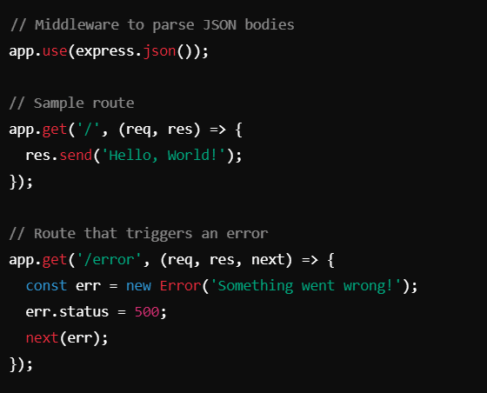

1. **How do you handle POST requests in Express.js?**

Ans: Handling POST requests in Express.js involves defining routes that respond to HTTP POST method and extracting data from the request body.

